

Business Analytics
Project
Nuruzova Yasmina

Introduction

Unemployment remains one of the most important macroeconomic indicators because it reflects the overall health of the labor market and the broader economy. Changes in unemployment are often associated with fluctuations in economic growth, inflation, and international trade conditions. Understanding these relationships is essential for evaluating economic stability and designing effective policy responses.
This project examines the relationship between GDP growth and unemployment in selected European countries over time. In addition to GDP growth, the analysis also considers inflation and trade openness as control variables, since they may influence labor market outcomes. The use of panel data allows the study to capture both time variation and differences across countries, making the analysis more informative than a single-country time series.
The main objective of this project is to investigate whether stronger economic growth is associated with lower unemployment rates. The study also aims to identify the role of inflation and trade openness in explaining unemployment dynamics and to explore whether the observed trends can be smoothed and forecasted.
Research Question:
How does GDP growth affect unemployment rates across selected European countries over time?

Data Description
The dataset combines macroeconomic indicators for selected European countries over time and is structured as a panel dataset.
The main data sources are:
- World Bank Open Data (data.worldbank.org): Provides internationally comparable macroeconomic indicators, including GDP growth, unemployment, inflation, and trade openness.
- OECD Data Explorer (oecd.org): Provides additional economic and labor market statistics for OECD and European countries, supporting the consistency and interpretation of the dataset.

Variables and Measurements

Dependent Variable:
- Unemployment Rate (%): The percentage of the total labor force that is unemployed but actively seeking employment. This variable reflects labor market conditions and serves as the main outcome variable in the analysis.

Independent Variable:
- GDP Growth Rate (%): The annual percentage growth rate of gross domestic product. This variable is used as the main explanatory factor, since stronger economic growth is generally expected to reduce unemployment through increased production and labor demand.

Control Variables:
- Inflation Rate (%): The annual percentage change in the general price level. Inflation is included as a control variable because changes in prices may influence economic activity, purchasing power, and employment conditions.
- Trade Openness (% of GDP): The sum of exports and imports expressed as a percentage of GDP. This variable captures the degree of economic integration with international markets and may affect employment through trade expansion, competitiveness, and external demand.
- Economic theory suggests a relationship between inflation and unemployment, commonly explained by the Phillips Curve, which implies a short-run trade-off between the two variables. However, this relationship may weaken in the long run due to structural and macroeconomic factors.

Panel Identifiers:
- Country: Identifies the country for each observation.
- Year: Represents the time dimension of the dataset.

Time Frame:
- 2013–2024: A 12-year period that provides sufficient variation across both time and countries.

Econometric Model Specification
𝑼𝑵𝑬𝑴𝑷i𝒕 = 𝜷𝟎 + 𝜷𝟏 GDPGR_{it} + 𝜷𝟐 INF_{it} + 𝜷𝟑 OPEN_{it} + 𝒆_{it}
- UNEMP_{it} = unemployment rate in country i at time t
- GDPGR_{it} = GDP growth rate
- INF_{it} = inflation rate
- OPEN_{it} = trade openness
- e_{it} = error term

Hypotheses
- 𝑯𝟎: GDP growth, inflation, and trade openness have no significant effect on unemployment rates.
- 𝑯𝟏: GDP growth, inflation, and trade openness have a significant effect on unemployment rates.

Potential Endogeneity Issues
- Reverse causality: Unemployment can also affect GDP growth by lowering production, consumption, and economic activity.
- Omitted variable bias: Other factors, such as labor policies, investment, productivity, or external shocks, may influence both GDP growth and unemployment.
- Country-specific effects: Differences in institutions, industrial structure, and labor market flexibility across countries may affect the relationship.
Descriptive Statistics
Variable | Mean | Std. Dev. | Min | Max
Unemployment Rate (%) | 7.7 | 5.7 | 2 | 26.1
GDP Growth Rate (%) | 1.8 | 3.1 | -11.2 | 6.9
Inflation Rate (%) | 2.6 | 3.2 | -0.9 | 15.1
Trade Openness (% of GDP) | 93.6 | 34 | 58.3 | 161

Time Series Analysis

This line graph shows that unemployment generally declined across the selected countries over time. Spain had the highest unemployment throughout most of the period, while Germany, Czechia, and Poland maintained relatively low rates.

This chart shows the evolution of inflation rates over time, with Germany and Spain presented as examples. This chart shows that inflation was low and fairly stable in the earlier years but rose sharply in 2021–2022 before declining again. This indicates increased price volatility in the later part of the period.

This scatter plot with the fitted trendline suggests a weak negative relationship between unemployment and inflation. However, the points are quite dispersed, indicating that inflation alone does not strongly explain unemployment differences.

This bar chart compares the average unemployment rate across the selected countries. Spain has the highest average unemployment rate, followed by France, while Czechia and Germany show the lowest average levels. This suggests substantial cross-country differences in labor market conditions over the period.

Smoothing the Data
This line graph presents the smoothed unemployment rate across the selected European countries using a 3-year centered moving average. The smoothed series confirms a general downward trend in unemployment over time, with Spain remaining the country with the highest unemployment level throughout the period, while Germany, Czechia, and Poland maintained relatively low and stable rates. By reducing short-term fluctuations, the graph makes the long-term improvement in labor market conditions more visible across the selected countries.

Variable | Rationale for Smoothing
Unemployment Rate (%) | To reduce short-term fluctuations and highlight the long-term labor market trend across countries

Example: Smoothed Unemployment Rate
Year |  | Raw Value (%) | Smoothed (MA) (%)
2013 |  | 5.2 | -
2014 |  | 5 | 4.9
2015 |  | 4.6 | 4.5
2016 |  | 4.1 | 4.1
... |  | ... | ...
2024 |  | 3.3 | -

Interpretation of Results
The smoothed unemployment rate confirms that labor market conditions generally improved over the period 2013–2024. Although smoothing was applied to highlight long-term trends, the original unemployment series was already relatively stable, making this step not essential for the analysis.
OLS Regression Results
Using statistical software, the regression model was estimated, and the following results were obtained.
Variable | Coefficient | Std. Error | t-Statistic | P-Value
Intercept | 16.92 | 1.78 | 9.49 | 0
GDP Growth Rate (%) | 0.02 | 0.2 | 0.12 | 0.908
Inflation Rate (%) | -0.35 | 0.2 | -1.73 | 0.09
Trade Openness (% of GDP) | -0.09 | 0.02 | -4.75 | 0
R-squared | 0.38
Adjusted R-squared | 0.34
Key Findings:
- GDP Growth Rate : Coefficient of 0.02, not statistically significant (p = 0.908).
- Inflation Rate : Coefficient of -0.35, not statistically significant at the 5% level (p = 0.090).
- Trade Openness: Coefficient of -0.09, highly significant (p = 0.000).
Model Fit:
- R-squared of 0.38: Indicates that 38% of the variation in unemployment rates is explained by the model.
- Adjusted R-squared of 0.34: After adjusting for the number of predictors, the model still shows moderate explanatory power.
Results:
- The regression results suggest that trade openness has a statistically significant negative effect on unemployment.
- Trade openness can reduce unemployment because more international trade often means more production, more business activity, and more jobs.
- GDP growth does not show a significant effect in this specification.
- Inflation shows a negative coefficient, but its effect is not statistically significant at the conventional 5% level.

Multicollinearity
Correlation Matrix:
 | gdp_growth | unemployment_rate | inflation | trade_openness
gdp_growth | 1
unemployment_rate | -0.08306718 | 1
inflation | 0.123900609 | -0.349324642 | 1
trade_openness | 0.135774865 | -0.584617135 | 0.30077338 | 1

Variance Inflation Factor (VIF): Measures how much the variance of the estimated regression coefficients is increased due to multicollinearity.
Variable | VIF
GDP Growth Rate (%) | 1.026715696
Inflation Rate(%) | 1.108025496
Trade Openness (% of GDP) | 1.111506207

VIF values are all close to 1 and well below the commonly used threshold of 5, indicating that multicollinearity is not a concern in this model. This suggests that the independent variables do not exhibit strong linear relationships with one another, and the regression coefficients can be interpreted more reliably.

Shapiro-Wilk test for normality
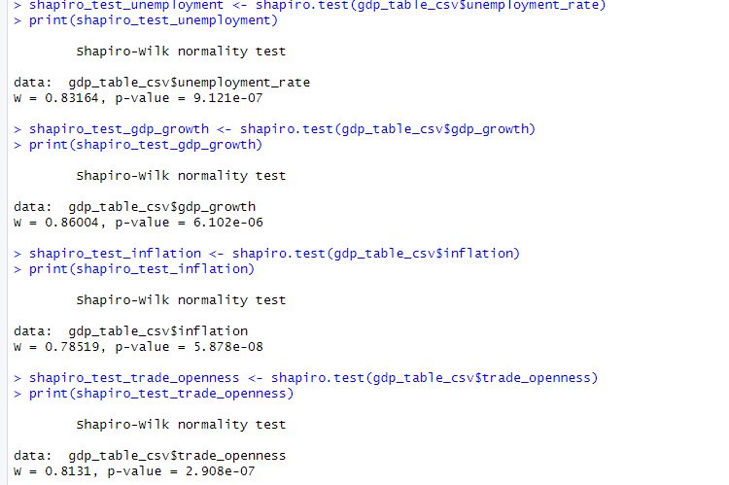
All variables fail the Shapiro-Wilk test for normality since their p-values are much smaller than 0.05. This suggests that the data for unemployment rate, GDP growth, inflation, and trade openness do not follow a normal distribution.
Then we apply Robust Regression techniques:
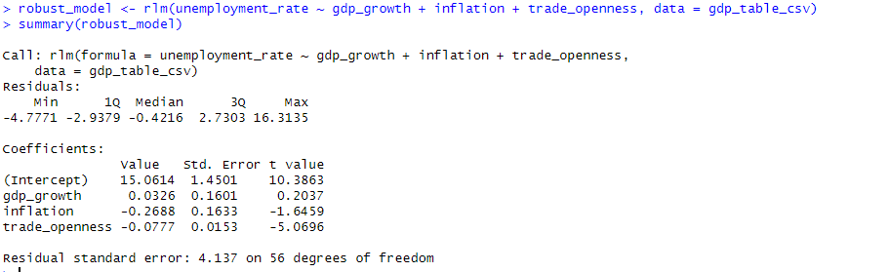
The robust regression results show that GDP growth and inflation have an insignificant effect on unemployment, while trade openness has a negative but also insignificant impact. The residual standard error of 4.137 suggests moderate error in the model. Overall, the model is reliable, but the low significance of the coefficients indicates that further refinement is needed.

Autocorrelation
Durbin-Watson Statistic: Measures the presence of autocorrelation in the residuals.
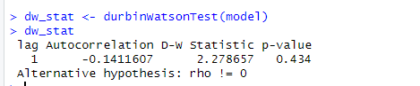
• Value: 2.28
Interpretation:
this value indicates no significant autocorrelation in the residuals. A value close to 2 suggests that the residuals are not correlated, which is generally desirable for regression analysis.

Heteroscedasticity
Breusch-Pagan Test: Tests for constant variance of the errors (homoscedasticity).
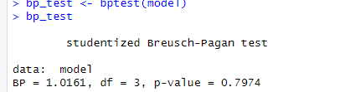
- BP statistic = 1.02
- p-value = 0.7974
Interpretation:
Since the p-value > 0.05, we fail to reject the H0 of homoscedasticity. This indicates that heteroscedasticity is not a concern, and the error terms have constant variance.

Panel estimation analysis
1. Fixed Effects Model (FE)
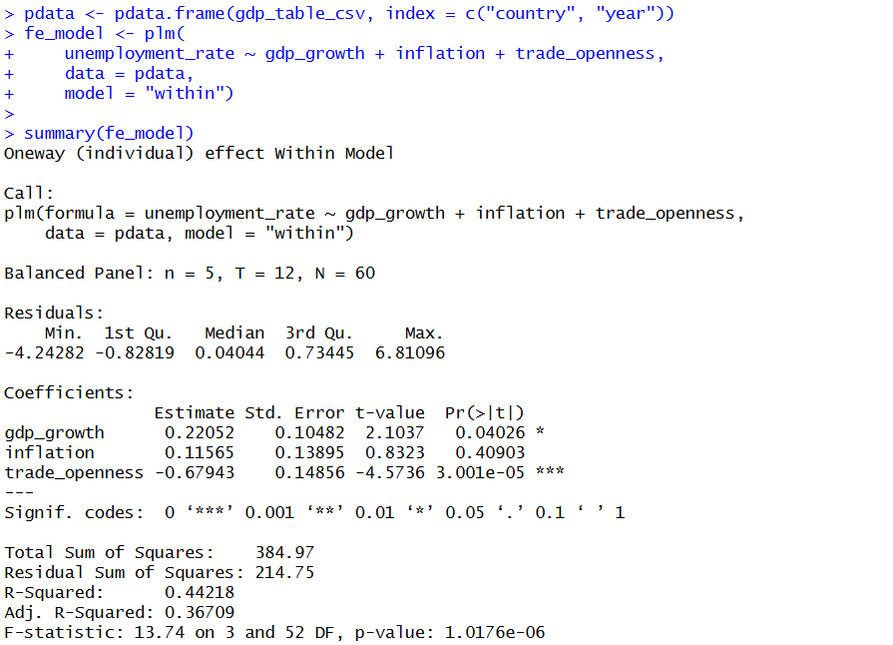
The Fixed Effects model shows that GDP growth has a positive and statistically significant effect on unemployment, suggesting that higher economic growth is associated with changes in unemployment within countries over time. Trade openness has a strong negative and highly significant effect, indicating that increased integration into global markets reduces unemployment. Inflation does not appear to have a statistically significant impact.

2. Random Effects Model (RE)
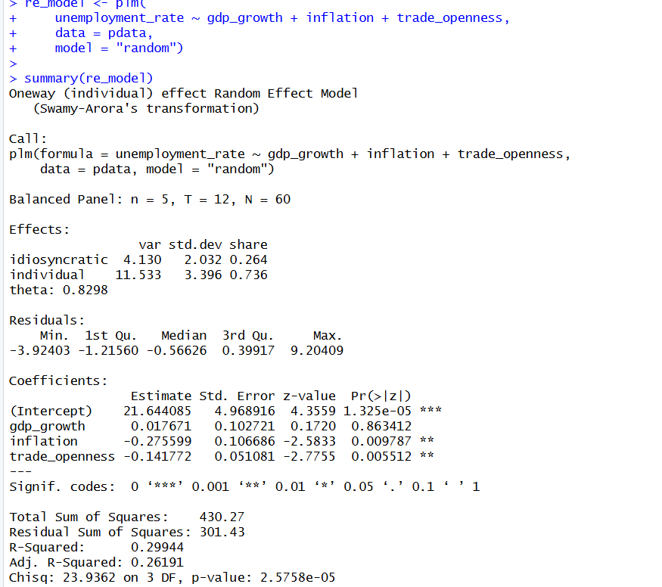
The Random Effects model suggests that inflation and trade openness have significant negative effects on unemployment, while GDP growth remains insignificant. This indicates that macroeconomic stability and openness may play a role in reducing unemployment across countries.
3. Hausman Test and Robust Standard Errors
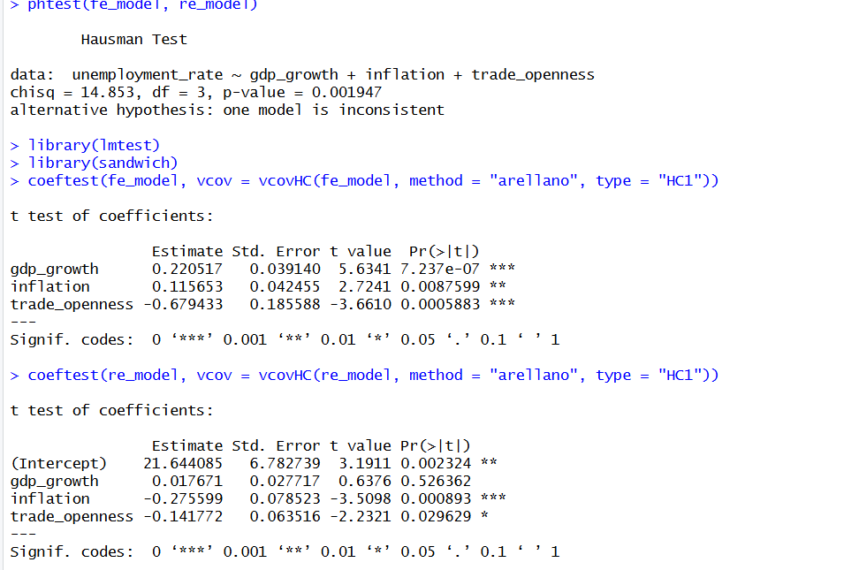

After applying robust standard errors, all variables become statistically significant. This suggests that previous insignificance may have been caused by heteroskedasticity or model misspecification. The results confirm that GDP growth and inflation positively affect unemployment, while trade openness reduces it. So, our final model is Fixed Effects with robust standard errors.
In conclusion, Based on the Hausman test, the Fixed Effects model is preferred. The robust estimation further strengthens the results, showing that GDP growth and inflation positively affect unemployment, while trade openness has a strong negative effect. These findings highlight the importance of country-specific factors and confirm that panel estimation provides more reliable results than simple OLS.

2SLS regression
- 2SLS was applied to address potential endogeneity between GDP growth and unemployment, as reverse causality may exist (unemployment can also affect economic growth)
Creating lag_gdp_growth:
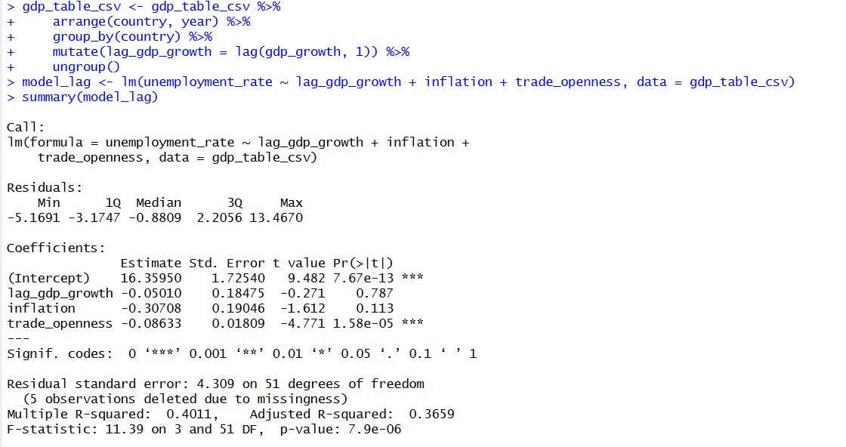
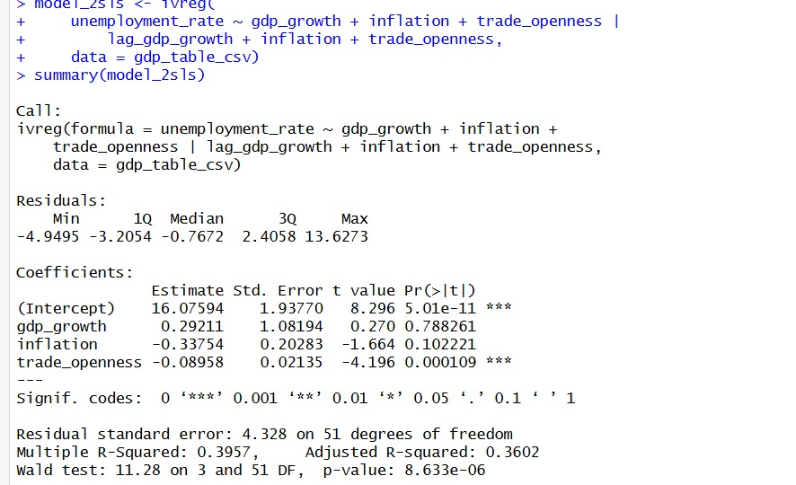

2sls model:
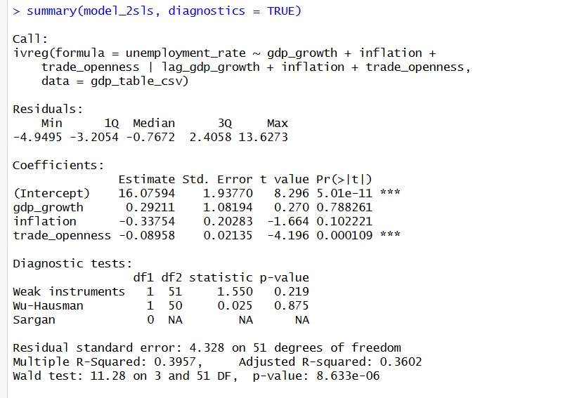

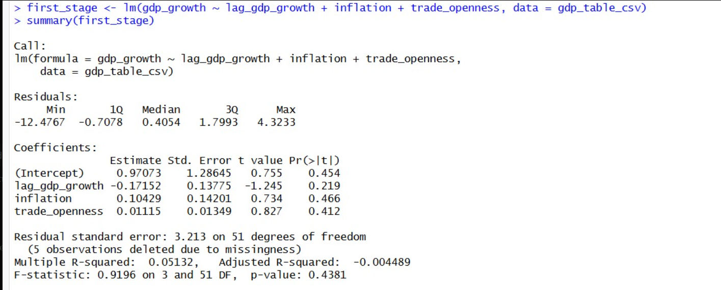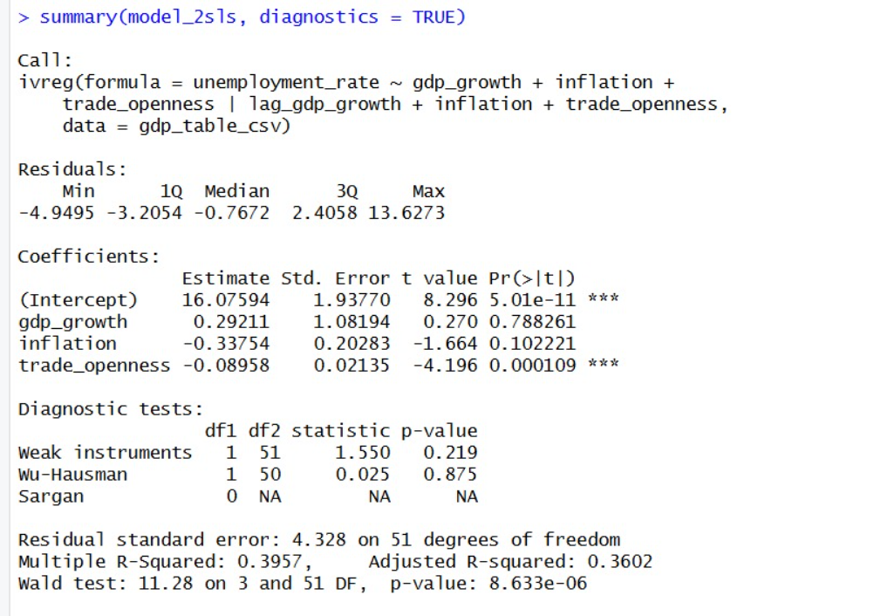
The instrument, lagged GDP growth, is weak. The Wu-Hausman test (p = 0.875) failed to reject the null hypothesis of exogeneity, suggesting that GDP growth was considered potentially endogenous, the 2SLS results and Wu-Hausman test do not provide evidence of endogeneity. Therefore, the Fixed Effects model remains the preferred specification.

Policy Implications
Based on the findings from this study, the following policy recommendations can help reduce unemployment across selected European countries:
- Enhance Trade Openness:
  - Since trade openness has a significant negative effect on unemployment, policies that promote international trade and economic integration are crucial. This can include trade agreements, reducing trade barriers, and supporting industries that benefit from global markets. By expanding trade, countries can increase production, create more jobs, and improve labor market conditions.
- Promote Economic Growth:
  - While GDP growth did not show a statistically significant effect on unemployment in this study, its potential role should not be overlooked. Policies that encourage investment, innovation, and infrastructure development can boost GDP growth, which may indirectly contribute to lower unemployment rates. Focus on fostering stable economic growth can create more job opportunities in the long term.
- Invest in Education and Workforce Development:
  - Even though this project did not focus on education indicators, investing in human capital remains a key strategy for reducing unemployment. Governments should prioritize policies that improve education, vocational training, and skill development to ensure a workforce that can meet the needs of modern industries. This will increase employability and reduce unemployment, especially among younger and lower-skilled populations.
- Monitor Inflation and Economic Stability:
  - While inflation was not statistically significant in the model, inflation can have indirect effects on unemployment, especially in times of economic instability. Policymakers should implement measures to control inflation and ensure price stability, as this can positively affect job security and economic confidence.
- Encourage Flexible Labor Market Policies:
  - The variability in unemployment across countries suggests that differences in labor market flexibility may play a role in unemployment rates. Implementing flexible labor market policies, such as reducing rigid hiring and firing processes, could help adapt to changing economic conditions, encouraging job creation while protecting workers' rights.

Conclusion
This project examined the relationship between GDP growth and unemployment using panel data for selected European countries. While initial OLS results suggested that only trade openness was significant, panel estimation provided more reliable insights. The Fixed Effects model, supported by the Hausman test, showed that GDP growth and inflation have statistically significant positive effects on unemployment, while trade openness has a strong negative impact.
Robust standard errors further confirmed the significance of all variables, highlighting the importance of controlling for heterogeneity and model assumptions. The 2SLS analysis did not find evidence of endogeneity, supporting the use of the Fixed Effects model as the main specification.
Overall, the results demonstrate that panel data methods provide more accurate and meaningful conclusions than simple OLS, emphasizing the role of trade openness and country-specific factors in explaining unemployment dynamics.

